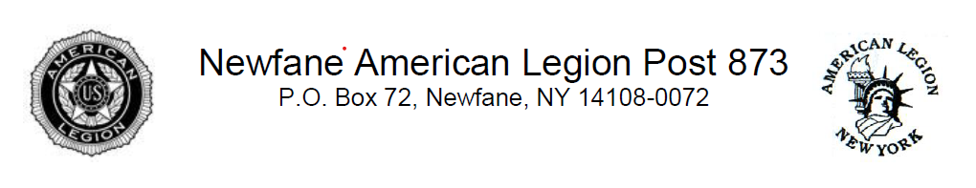
Lester Oakes Memorial American History Scholarship Application

Name:
Address:
City: State: Zip Code:
Home Phone Number:
Name of College/Trade School You Plan to Attend:
Anticipated College Major/Trade School Study:
Honors and Awards: (Use additional sheets if needed)
Examples: National Honor Society, Academic Awards, Athletic Awards, Highest Average Award, HOBY Ambassador, Business First Honors, Girls/Boys State, Eagle Scout/Gold/Silver Awards, All-State/County (Music), All-League (Sports), etc.
-

Leadership Positions Held: (Elected or Appointed)
Examples: Student Senate, Class Officer, Athletic Team Captain, etc.
-

Community Service Activities:
Examples: volunteer services, community projects, church volunteerism, tutoring, junior fireman, etc.
-

Extracurricular Activities:
Examples: athletics, youth groups, tech and motor sports club, science club, FIRST Robotics, school musical/play, drama club, band, jazz/symphonic/wind ensemble band, part-time employment , Model U.N., yearbook staff, etc.
-

Essay:

